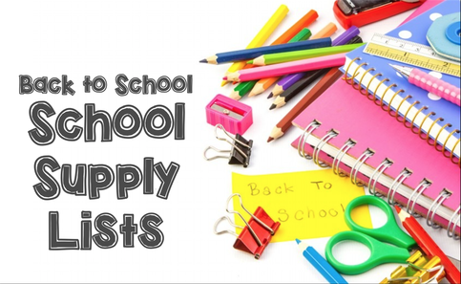

Hello NMS Families!
Just a quick reminder that students are to pay a $50.00 student fee which their school supplies will be purchased from. As well as their student fees, students are asked to bring with them a backpack, a lunch box, a pair of non-marking sneakers, two boxes of Kleenex, a water bottle, a box of large Ziplock bags, a box of small Ziplock bags and a pair of earbuds/earphones.

Thanks so much!
Grade 4 French Immersion Teaching Team

